**UI Design Project**

1.

* Login-1
  + The mobile design for our twitter application UI starts at the login page. Users may input login information or click the register button if they need to make an account.
* Register-2
  + The register button directs to a page where they are asked to input full name, username, email, password, and password strength. This page will display an error if input is incorrect.
* There are buttons at the top of each page after login, which direct the user to various functions. From left to right they are home(house), me(person), liked posts(star), search(magnifying glass), settings(cog), and exit(x). Buttons will be highlighted if the user is on that particular page.
* Homepage-3
  + After logging in the user goes to the homepage which allows them to post, look at posts from people they follow, or look at their own posts. Posts contain name, username, body, and timestamp. Each post also has a reply and like button on the bottom. The like button will be toggled based if they have already liked the post.
* Me-4
  + The Me page will show followers/following and information about those people. This page includes a like button which is toggled based on whether the user is following that person. The liked posts page shows posts that the user has liked.
* Liked Posts-5
  + The star button directs the user to the liked post page. This page shows posts the user has liked with options to sort them based on date and amount of likes.
* Search-6/7
  + The search button directs the user to a blank page with the option to input a search parameter which can be a user or text. After clicking search the user is directed to a page which displays the search terms and shows relevant posts.
* User Page-8
  + If the user clicks on the username on any post they will be directed to a page which displays that person’s posts, bio message, follow counts, and follow status.
* Settings-9
  + Clicking the settings button will show user information and allow them to edit bio or password.
* Exit-10
  + The exit button takes the user to page where they can logout.

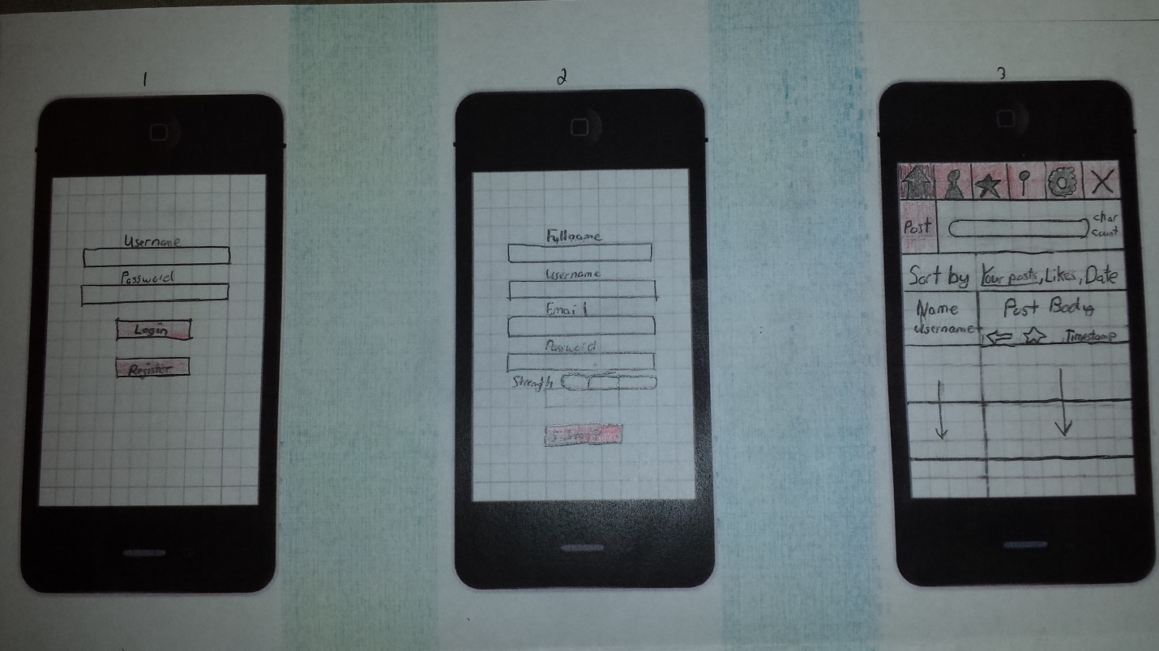

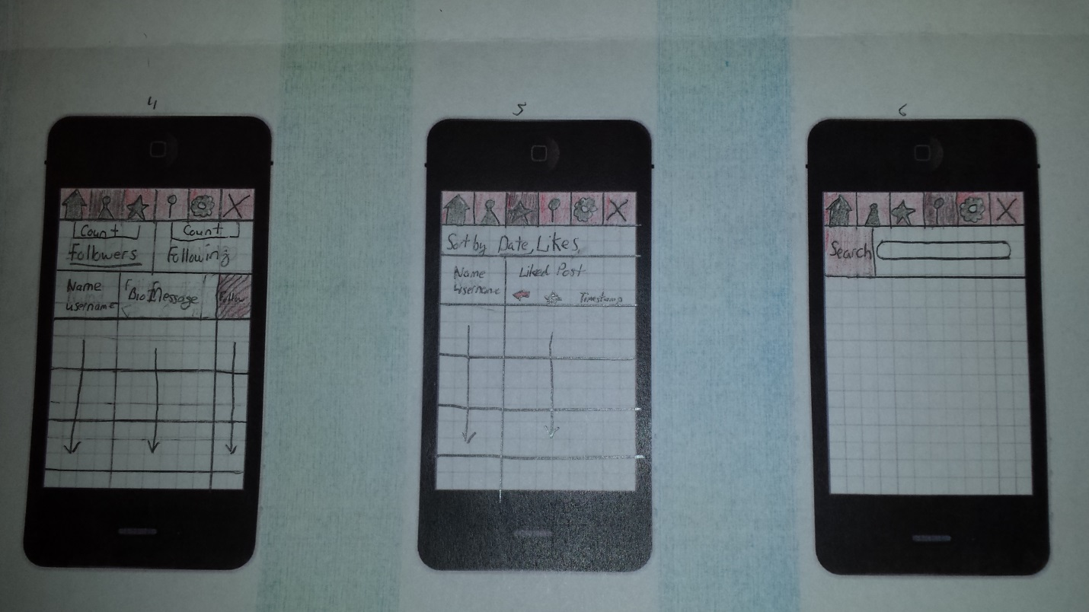

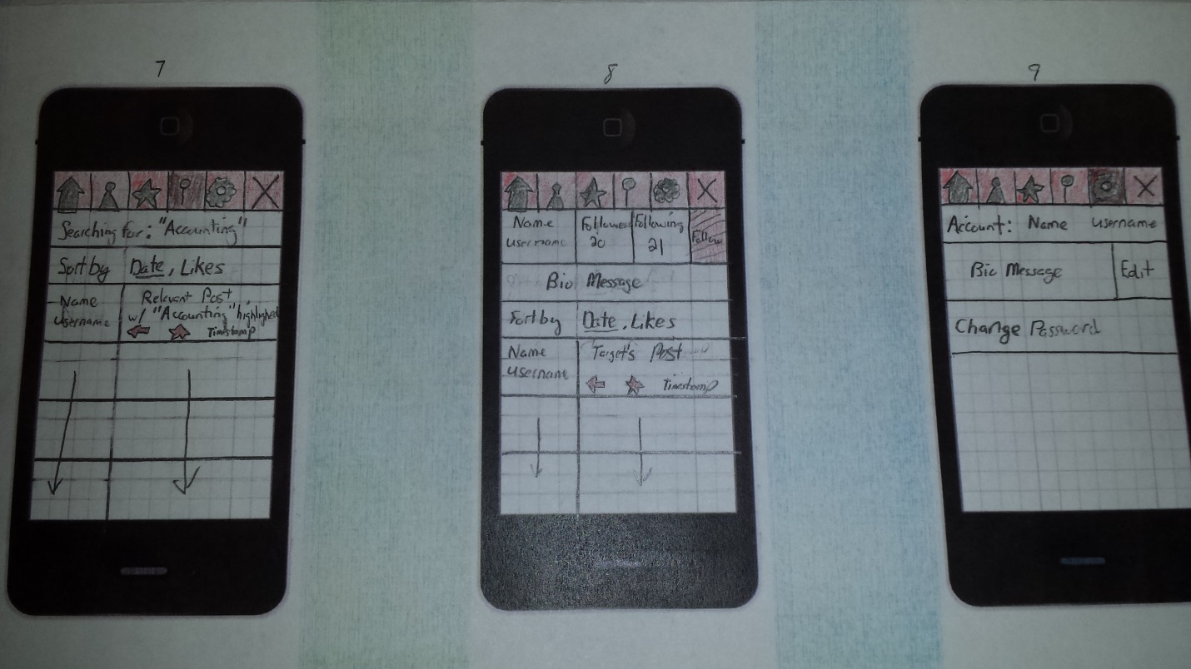

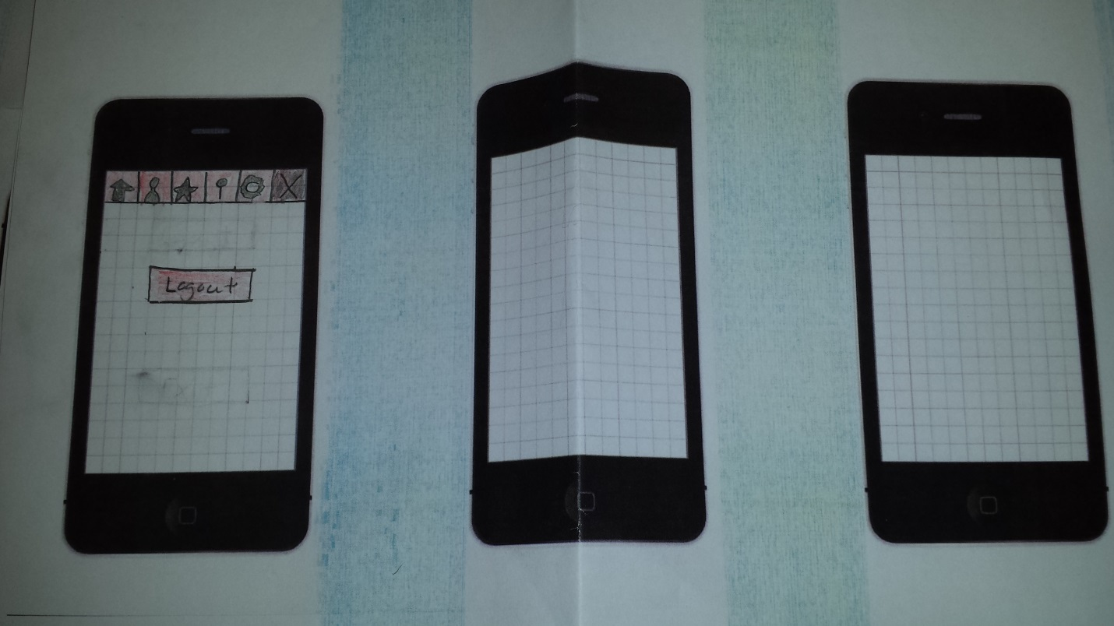

10

2. This design was chosen based on the principles discussed in the activity. The application separates functions on pages while giving the user an easy way to jump between them.

3. The final iteration was based on the ones completed in class. These first iterations gave us a good idea of how to implement the mobile design which involved separating functions and avoiding cluttering the pages.

4.

1. Serial Position Effect
   1. The first and last elements of a list are more easily remembered than the middle elements.
      1. This principle is applied throughout the design of this UI. The top buttons implement it by placing the home and exit buttons as first/last. These buttons will have the highest amount of clicks. Every page follows the same format with relevant information directly beneath the buttons, followed by a list of posts or users. This ensures the user will see that information before they read posts.
      2. This principle is important because readability is a key factor when dealing with mobile design. Phones have small screens so displaying information becomes dependent on vertical scrolling.
      3. This principle is applied for anything involving lists on the application.
2. Priming
   1. If you show a person an image, then a memory/association will be drawn up from their mind about it.
      1. The principle could be applied by keeping images professional, since the site we are making is supposed to be a business website.
      2. The principle can lead to the success of the site by making people who use the site feel a certain way. As in the previous point, we could make our website professional looking and have people think of that.
      3. This principle could be also applied in subtle ways such as putting a lock by the password to help people make a strong password.
3. Delighters
   1. A way to form a cognitive connection with the user based on giving them an unexpected surprise. It can be a compliment, a joke, or an easter egg based on what they just did.
      1. I would apply the principle by using small bubble-like messages next to the text boxes. For example, when the user is setting their password and it is determined to be a strong password, I would show a message like, “Nice password!” This could also be used with the username, based on if it is a unique username. If it’s not already taken: “How unique!” or “I would follow that user’s posts in a heartbeat.”
      2. These messages would not distract from the purpose of the task at hand and would form a memorable connection with the user that they might not get from another similar service. The more favorable connection the user has with the website, especially one that conveys that they care about what they have to say, the more likely the user may be to continue using the service.
      3. There may be opportunities to tell the user coding hints based on the hash tags of their posts. For example, we can recognize that a user hash tagged their post with #recursion. We could then show another bubble-like message. “Did you know, most recursive algorithms have equivalent iterative, and less memory intensive solutions?”